# WDD 330 Final Project

Course: WDD 330

Instructor: Gary James

**Overview**

*What is the problem we are trying to solve?*

Create a fun trivia game that one can play at a quiz night with fellow YSA without the need for additional work by the coordinators of the game’s night.

*Why are we doing this?* I have found that a lot of these trivia games one wants to play at YSA nights always contain some microtransactions for specific topic or require a subscription if you want to create your own questions. The goal is to create a web application that can replace those apps free of charge.

**Who is the Audience?**

The main audience for the application will be the age group of teenagers and up that enjoy spending time either together or by themselves playing trivia games to pass time, practice general knowledge or sometimes even use the program to create small test for upcoming exams.

**Major Functions.**

1. Play random question trivia games.
2. Create your own trivia games that are stored locally on your device.
3. Allow Team vs Team quiz battles.
4. Pull a list of questions from a trivia API.

**Wireframes**

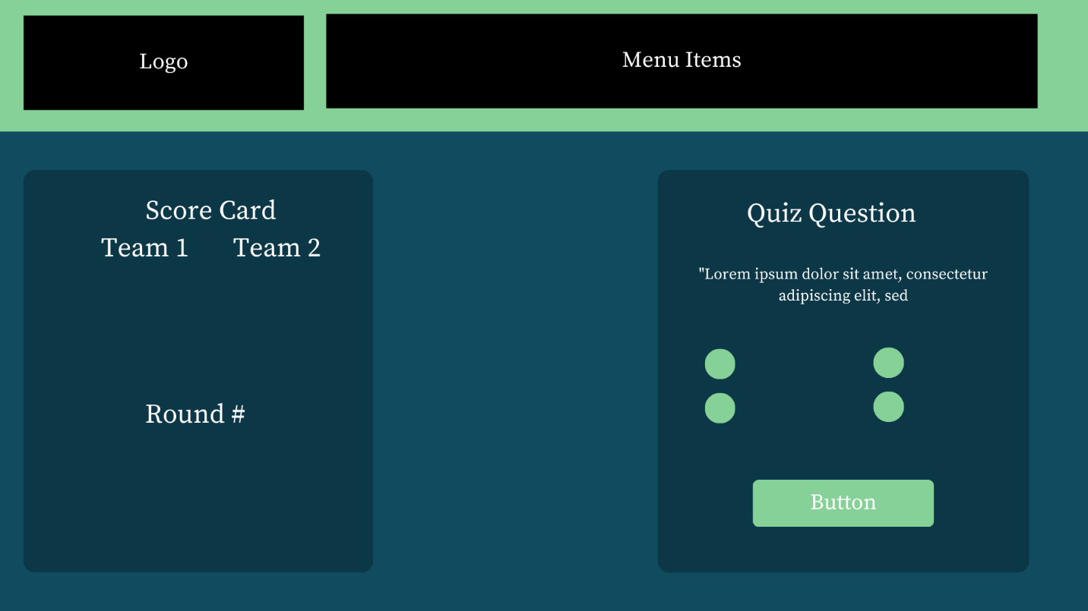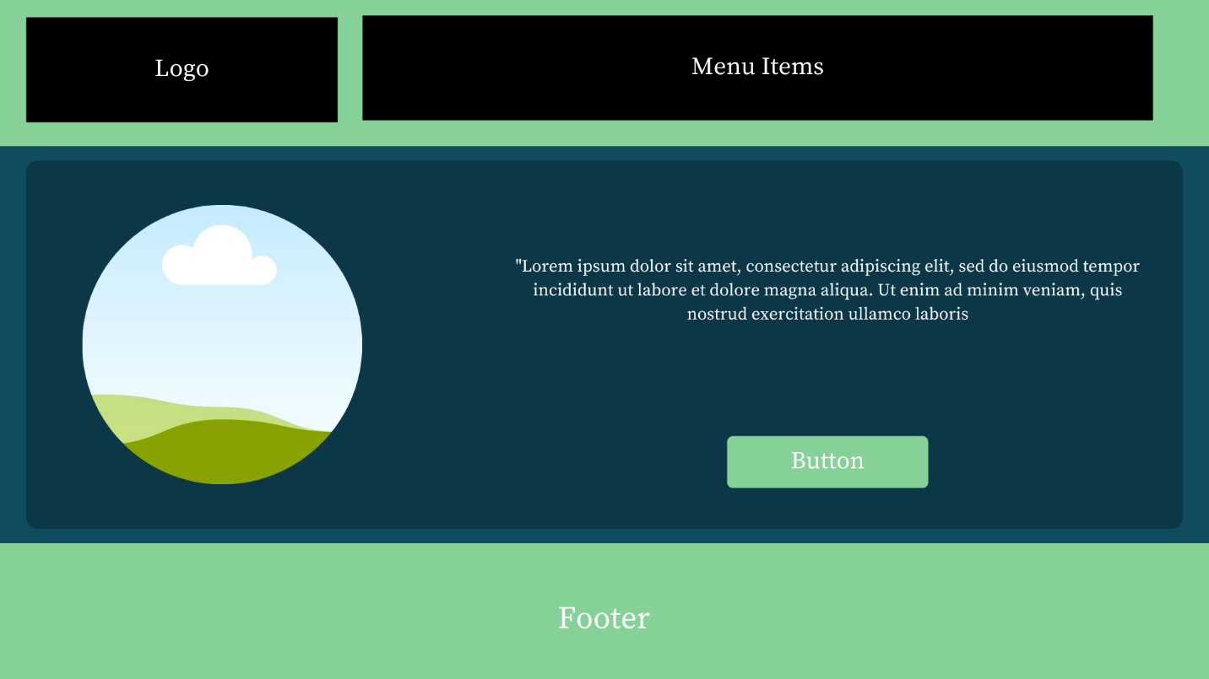

**Data Sources**

1. Open Trivia DB API
2. Local JSON Menu Items
3. Local Browser Storage for Custom Games.

**Initial Module List**

1. External Quiz Handler
2. Common Utils (Reading JSON Files, Rendering Templates, etc…)
3. Play Module (Checking Quiz Answers and Creating Quiz Pages)

**Colors / Typography / Specific Element Styles**

1. Dark background with purple accents
2. Helvetica and additional fallback fonts
3. Glowing buttons and sections to give the impression of glowing fun games.

**Schedule**

1. Week 1
   1. Fonts, Logos, Header, Footer. Buttons styling, Wireframes
   2. External API documentation reading and testing
2. Week 2
   1. Constructing of Home Page, Play Page
   2. Implementing API’s and LocalStorage
3. Week 3
   1. Complete Functional Custom Quizzes with rending
   2. Local Team vs Team Implementation

**Trello Link**

[**https://trello.com/b/aIr3A9gJ/wdd330-final-project**](https://trello.com/b/aIr3A9gJ/wdd330-final-project)